
Docusign Envelope ID: AF852C52-2792-434A-A9D9-99D84FC94D4C


Associate to Bachelors (A2B) Articulation Agreement
Prescribed Curriculum: Northeast Community College

Associate of Science – Physics

General Education Courses |  |  |  | 34 CREDIT HOURS
 | Credit Hours | Course No. | Course Title or Category
Written Comm | 3 | ENGL 2070 | Technical Communications I
Oral Communication | 3 | SPCH 1010 or 1110 | Fundamentals of Communication or Public Speaking
Behavioral & Social Sciences | 3 | Select 1 course from | AS General Education list (except AGRI 1530)
English/Literature | 3 | Select 1 course from | AS General Education list (except ENGL 1020)
Fine Arts and Language | 3 | Select 1 course from | AS General Education list
Mathematics | 10 | MATH 1600  MATH 2010 | Analytic Geometry and Calculus I  Analytic Geometry and Calculus II
Natural Science | 9 | CHEM 1090  PHYS 2110 | General Chemistry I  General Physics I w/Calculus

Required Courses |  |  | 17 CREDIT HOURS
 | Credit Hours | Course No. | Course Title
Mathematics & Science | 5 | PHYS 2120 | General Physics II w/Calculus
Mathematics & Science | 3 | MATH 2100 | Differential Equations
Mathematics & Science | 5 | MATH 2020 | Analytic Geometry and Calculus III
Mathematics & Science | 4 | CHEM 1100 | General Chemistry II

Program Elective Courses |  |  | 9 CREDIT HOURS
 | Credit Hours | Course No. | Course Title
Electives | 3 | ENGR 1020 | Programming and Problem Solving
Electives | 3 | MATH 2170 | Applied Statistics
Electives | 3 | ENGR 2020 | Engineering Statics

Associate of Science – Physics Total: | 60 CREDIT HOURS

Post-Associate Degree Prescribed Curriculum: South Dakota Mines

Bachelor of Science – Physics

General Education Courses |  |  |  | 6 CREDIT HOURS
 | Credit Hours | Course No. | Course Title or Category
Written Communication | 3 | ENGL 289 | Explorations in STEM Communications
Social Sciences | 3 | Select 1 course from | CIV 100, HIST 151, HIS 152, POLS 100, or POLS 210

Major Required Courses |  |  | 50 CREDIT HOURS
 | Credit Hours | Course No. | Course Title
Physics & Mathematics | 3 | PHYS 225 | Vibrations, Waves, and Optics
Physics & Mathematics | 2 | PHYS 312 | Experimental Physics Design I
Physics & Mathematics | 3 | PHYS 331 | Introduction to Modern Physics
Physics & Mathematics | 2 | PHYS 341 | Thermodynamics
Physics & Mathematics | 2 | PHYS 343 | Statistical Physics
Physics & Mathematics | 3 | PHYS 361 | Optics
Physics & Mathematics | 2 | PHYS 314 | Experimental Physics Design II
Physics & Mathematics | 3 | PHYS 350 | Advanced Physics Laboratory
Physics & Mathematics | 4 | PHYS 421 | Electromagnetism
Physics & Mathematics | 4 | PHYS 471 | Quantum Mechanics
Physics & Mathematics | 3 | PHYS 412 | Advanced Design Projects I
Physics & Mathematics | 4 | PHYS 451 | Classical Mechanics
Physics & Mathematics | 4 | PHYS 414 | Advanced Design Projects II
Physics & Mathematics | 4 | PHYS 433 | Nuclear and Elementary Particle Physics
Physics & Mathematics | 4 | PHYS 439 | Condensed Matter Physics
Physics & Mathematics | 3 | MATH 315 | Linear Algebra

Elective Courses |  |  | 4 CREDIT HOURS
 | Credit Hours | Course No. | Course Title
Program Electives | 4 | Select with Advisor | From list of approved electives

Post-Associate Degree Total: | 60 CREDIT HOURS

Bachelor of Science – Physics Total: | 120 CREDIT HOURS

A2B Articulation Agreement Guarantees & Limitations

GUARANTEES

Students who:
- complete the Associate of Science – Pre-Engineering degree prescribed curriculum at Northeast Community College exactly as it is identified in this articulation agreement, and
- have the degree conferred on their education record at Northeast Community College (post high school graduation), and
- earn a minimum cumulative grade point average (GPA) of 2.75 at the Northeast Community College, and
- pass all 60 credits for the associate degree, earning a grade C- or higher in each course

are guaranteed the following at the South Dakota School of Mines and Technology (South Dakota Mines):
- junior standing at South Dakota Mines with no more than 60 remaining credits to meet the graduation requirements for the Bachelor of Science degree in Physics.
- admission to South Dakota Mines
- admission to the Bachelor of Science degree in Physics.

LIMITATIONS
- This agreement is between the Associate of Science – Pre-Engineering degree at Northeast Community College and the Bachelor of Science degree in Physics at South Dakota Mines only.
- Students must meet all admission and application requirements at South Dakota Mines, including the submission of all required documentation by stated deadlines. Students are advised to contact the Office of Admissions at the South Dakota Mines early in their transfer planning.
- Student must have a cumulative grade point average (GPA) at the Northeast Community College of 2.75 or higher
and only courses with grades of C- or higher are guaranteed to be accepted in transfer by South Dakota Mines.
- The credit and course transfer guarantees described in this agreement apply to the Associate of Science – Pre- Engineering degree at Northeast Community College and the Bachelor of Science degree in Physics at South Dakota Mines. If the student changes majors at Northeast Community College or at South Dakota Mines, the student is no longer covered by this Articulation Agreement and none of the Guarantees of the Agreement apply.
- Students utilizing any form of transfer credit, including but not limited to credit awarded from other higher education institutions, standardized exam (CLEP, AP, DSST, etc.), prior learning assessment (military, certifications, ACE recommended credit, portfolio, challenge exam, work experience equivalent credit, etc.) to satisfy any Associate degree requirements will have those credits evaluated by South Dakota Mines. Should South Dakota Mines not accept the transfer credits accepted by Northeast Community College, the student will be required to make up the credit deficiency at South Dakota Mines.
- No course substitutions are allowed for the courses listed in the Prescribed Curriculum for the associate degree at Northeast Community College.

A2B CONTACT INFORMATION
South Dakota Mines Northeast Community College
Office of the Provost Registration Office
605.394.2256 402.844.7265
Provost@sdsmt.edu

RENEWAL, REVISION, and TERMINATION
- This Associate to Bachelor Articulation Agreement (A2B) shall be in effect July 1 – June 30 each year and will automatically renew annually unless action is taken by South Dakota Mines or Northeast Community College to terminate or modify it.
- The South Dakota Mines Office of the Provost and the Northeast Community College Academic Affairs division will collaborate to coordinate a review of the content of the associate and bachelor degrees on a three-year cycle to ensure this A2B is still appropriate.
- South Dakota Mines and the Northeast Community College each reserve the right to seek revision of this agreement at any time.
- Revision of any content of the agreement (except Appendices content) will be approved by each institution and result in a new agreement being signed, with copies retained by each institution.
  - Revision to any Appendices will be communicated to each institution, but do not need to be approved by each institution and will not result in a new agreement being signed by each institution.
- South Dakota Mines and the Northeast Community College each reserve the right to seek termination of this agreement at any time.
- Should the agreement be terminated, each institution agrees to collaborate and engage in appropriate plans to notify and work with impacted students, providing a minimum one-year advance notice of termination.

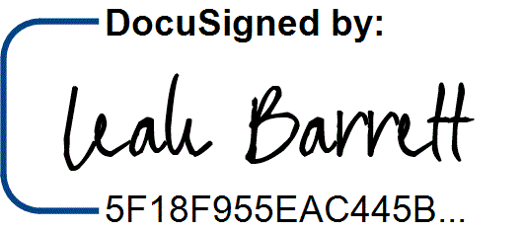
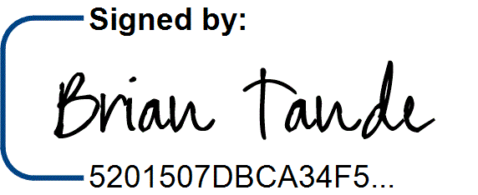
APPROVALS

 | 8/5/2025 |  | 8/4/2025
Brian Tande, Ph.D.  President | Date | Leah Barrett, Ed.D.  President | Date
South Dakota Mines |  | Northeast Community College
Brian.Tande@sdsmt.edu |  | lbarrett@northeast.edu
 | 8/5/2025 |  | 8/4/2025
Lance Roberts, Ph.D. | Date | Charlene Widener, Ph.D. | Date
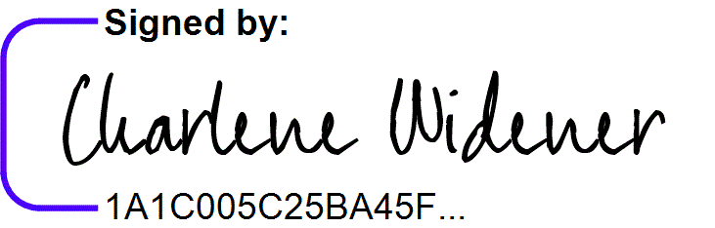
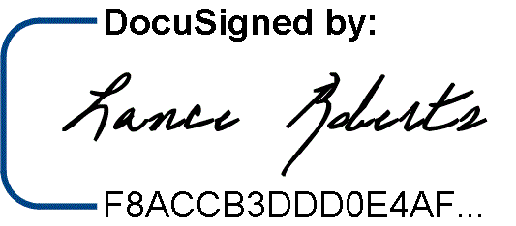
Provost and Vice President for Academic Affairs Vice President of Educational Services South Dakota Mines Northeast Community College
Lance.Roberts@sdsmt.edu cwidener@northeast.edu

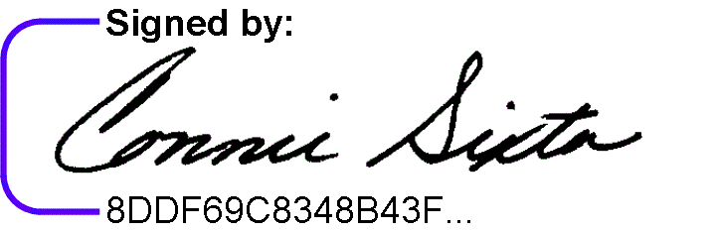
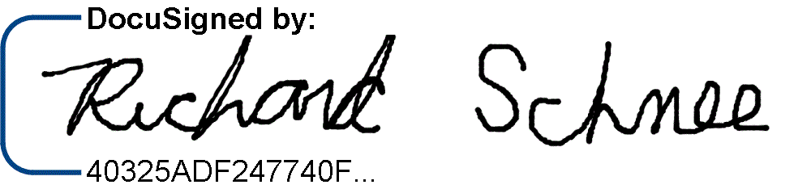
8/5/2025 7/25/2025
Richard Schnee, Ph.D. Date Connie Sixta Date Department Head Dean of Science, Technology, Agriculture & Math
South Dakota Mines Northeast Community College
Richard.Schnee@sdsmt.edu connie@northeast.edu

Appendix A: Course Sequence


Course Sequence: Northeast Community College

Physics (A.S.)

Semester | Course No. | Course Title | Credit Hours | Completed
Freshman | ENGL 2070 | Technical Communications I | 3
Year
Year | MATH 1600 | Analytic Geometry and Calculus I | 5
First
First | CHEM 1090 | General Chemistry I | 4
Semester
Semester | Select 1 course from | General Education: Fine Arts and Language | 3
 |  | Total Credits | 15

Semester | Course No. | Course Title | Credit Hours | Completed
Freshman | Select 1 course from | General Education: English/Literature (Except ENGL 1020) | 3
Year
Year | MATH 2010 | Analytic Geometry and Calculus II | 5
Second
Second | PHYS 2110 | General Physics I with Calculus | 5
Semester
Semester | CHEM 1100 | General Chemistry II | 4
 |  | Total Credits | 17

Semester | Course No. | Course Title | Credit Hours | Completed
Sophomore | Select 1 course from | General Education: Behavioral/Social Sci (Except AGRI 1530) | 3
Year
Year | MATH 2100 | Differential Equations | 3
First
First | PHYS 2120 | General Physics II with Calculus | 5
Semester
Semester | ENGR 2020 | Engineering Statics | 3
 |  | Total Credits | 14

Semester | Course No. | Course Title | Credit Hours | Completed
Sophomore | MATH 2020 | Analytic Geometry and Calculus III | 5
Year
Year | Select 1 course from | SPCH 1010 Fund of Comm or SPCH 1110 Public Speaking | 3
Second
Second | MATH 2170 | Applied Statistics | 3
Semester
Semester | ENGR 1020 | Programming and Problem Solving | 3
 |  | Total Credits | 14

General Education Coursework Total:  Major and Elective Coursework Total:  Northeast Community College Coursework Total: | 34 credit hours  26 credit hours  60 CREDIT HOURS


Course Sequence: South Dakota Mines – Fall Semester Start

Physics (B.S.)

Semester | Course No. | Course Title | Credit Hours | Completed
Junior Year First Semester  - FALL | PHYS 312 | Experimental Physics Design I | 2
Junior Year First Semester  - FALL | PHYS 331 | Introduction to Modern Physics | 3
Junior Year First Semester  - FALL | PHYS 343 | Statistical Physics | 2
Junior Year First Semester  - FALL | PHYS 341 | Thermodynamics | 2
Junior Year First Semester  - FALL | PHYS 361 | Optics | 3
Junior Year First Semester  - FALL | MATH 315 | Linear Algebra | 3
Total Credits 15

Semester | Course No. | Course Title | Credit Hours | Completed
Junior Year | PHYS 314 | Experimental Physics Design II | 2
Second
Second | PHYS 350 | Advanced Physics Lab | 3
Semester -
Semester - | PHYS 421 | Electromagnetism | 4
SPRING
SPRING | PHYS 471 | Quantum Mechanics | 4
 | Select 1 course from | Social Science (Goal 3) - Civics CIV 100, HIST 151, HIS 152, | 3
 | Select 1 course from | POLS 100, or POLS 210 | 3
 |  | Total Credits | 16

Semester | Course No. | Course Title | Credit Hours | Completed
Senior Year First Semester  - FALL | PHYS 412 | Advanced Design Projects I | 3
Senior Year First Semester  - FALL | PHYS 451 | Classical Mechanics | 4
Senior Year First Semester  - FALL | PHYS 225 | Vibrations, Waves & Optics | 3
Senior Year First Semester  - FALL | ENGL 289 | STEM Communications for Technical & Public Audiences | 3
Total Credits 13

Semester | Course No. | Course Title | Credit Hours | Completed
Senior Year | PHYS 414 | Advanced Design Projects II | 4
Second
Second | PHYS 439 | Condensed Matter Physics | 4
Semester -
Semester - | PHYS 433 | Nuclear & Elementary Particle Physics | 4
SPRING
SPRING |  | Program Electives | 4
 |  | Total Credits | 16

General Education Coursework Total:  Major and Elective Coursework Total:  South Dakota Mines Coursework Total: | 6 credit hours  54 credit hours  60 CREDIT HOURS

